Studio 9 & 10

Name and Student Id: Nicolas Pallant 28785959

Self-Evaluation:

|  |  |  |  |  |  |
| --- | --- | --- | --- | --- | --- |
| Need Help | Work in Progress | Pass | Credit | Distinction | High Distinction |

Task 9.1

Responsive Images

Old (1090 x 970)

New (320x284)

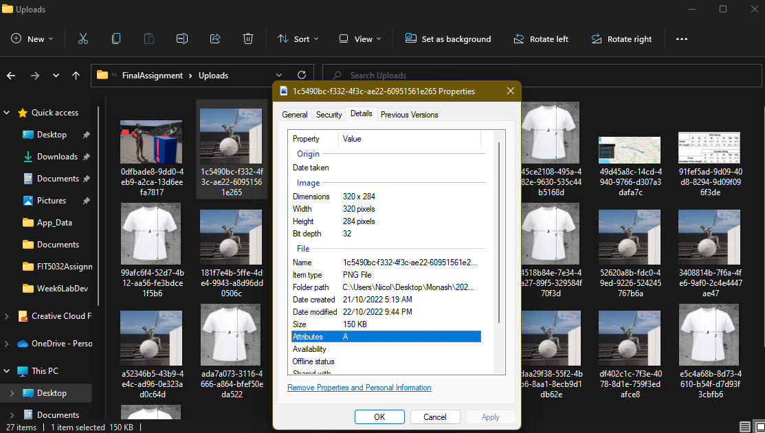

Old (1113 x 1150)

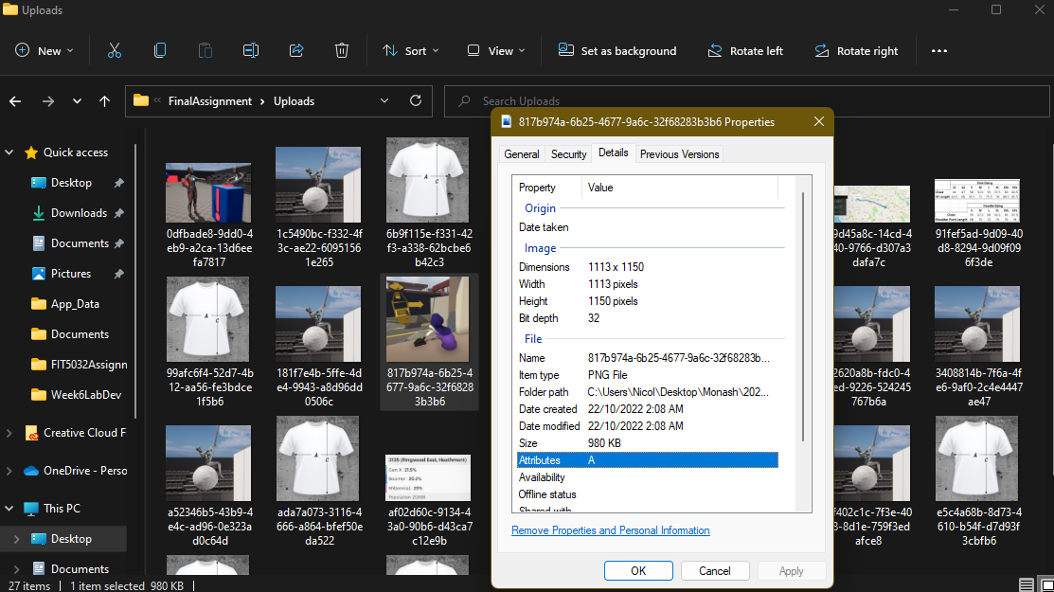

New (640 x 661)

.woff vs .woff2

.woff, or Web Open Font Format is a wrapper for TrueType and OpenType fonts. It makes it so that files are compressed and is supported by almost all modern browsers. (Not earlier versions of internet explorer)

.woff2, or Web Open Font Format 2 is built off of .woff and is an updated version. It offers smaller file sizes and better performance than any of font format, but is only supported by some modern browsers. For example, Microsoft edge, internet explorer, as well as safari and the default android internet browser.

So if you are targeting older broswers, .woff2 is unlikely to be supported, and .woff would be more likely, but still up in the air.

Task 9.2

.Net Core Vs ASP.Net Framework

* .Net core is fully open source whereas only some aspects of the .net framework are open source, making .net core more customizable as an application than .net framework.
* .Net core only allows for web, windows mobile, and windows store development, whereas .net framework supports desktop applications as well as the other windows applications.
* .Net core is much more flexible when it comes to compatibility with different devices. .Net framework is only compatible with windows, whereas .net core supports android development, IOS development, as well as Mac OS and linux.

Essentially if you are only developing for windows and on windows based devices, then you can use .net framework, but .net core is cross-platform, allows for significantly higher performance, and can target microservices.

Task 10.1

API Response

Github Repository

https://github.com/Ryukawastaken/FIT5032-Internet-Apps-Dev

Task 10.2

Angular.JS Application

